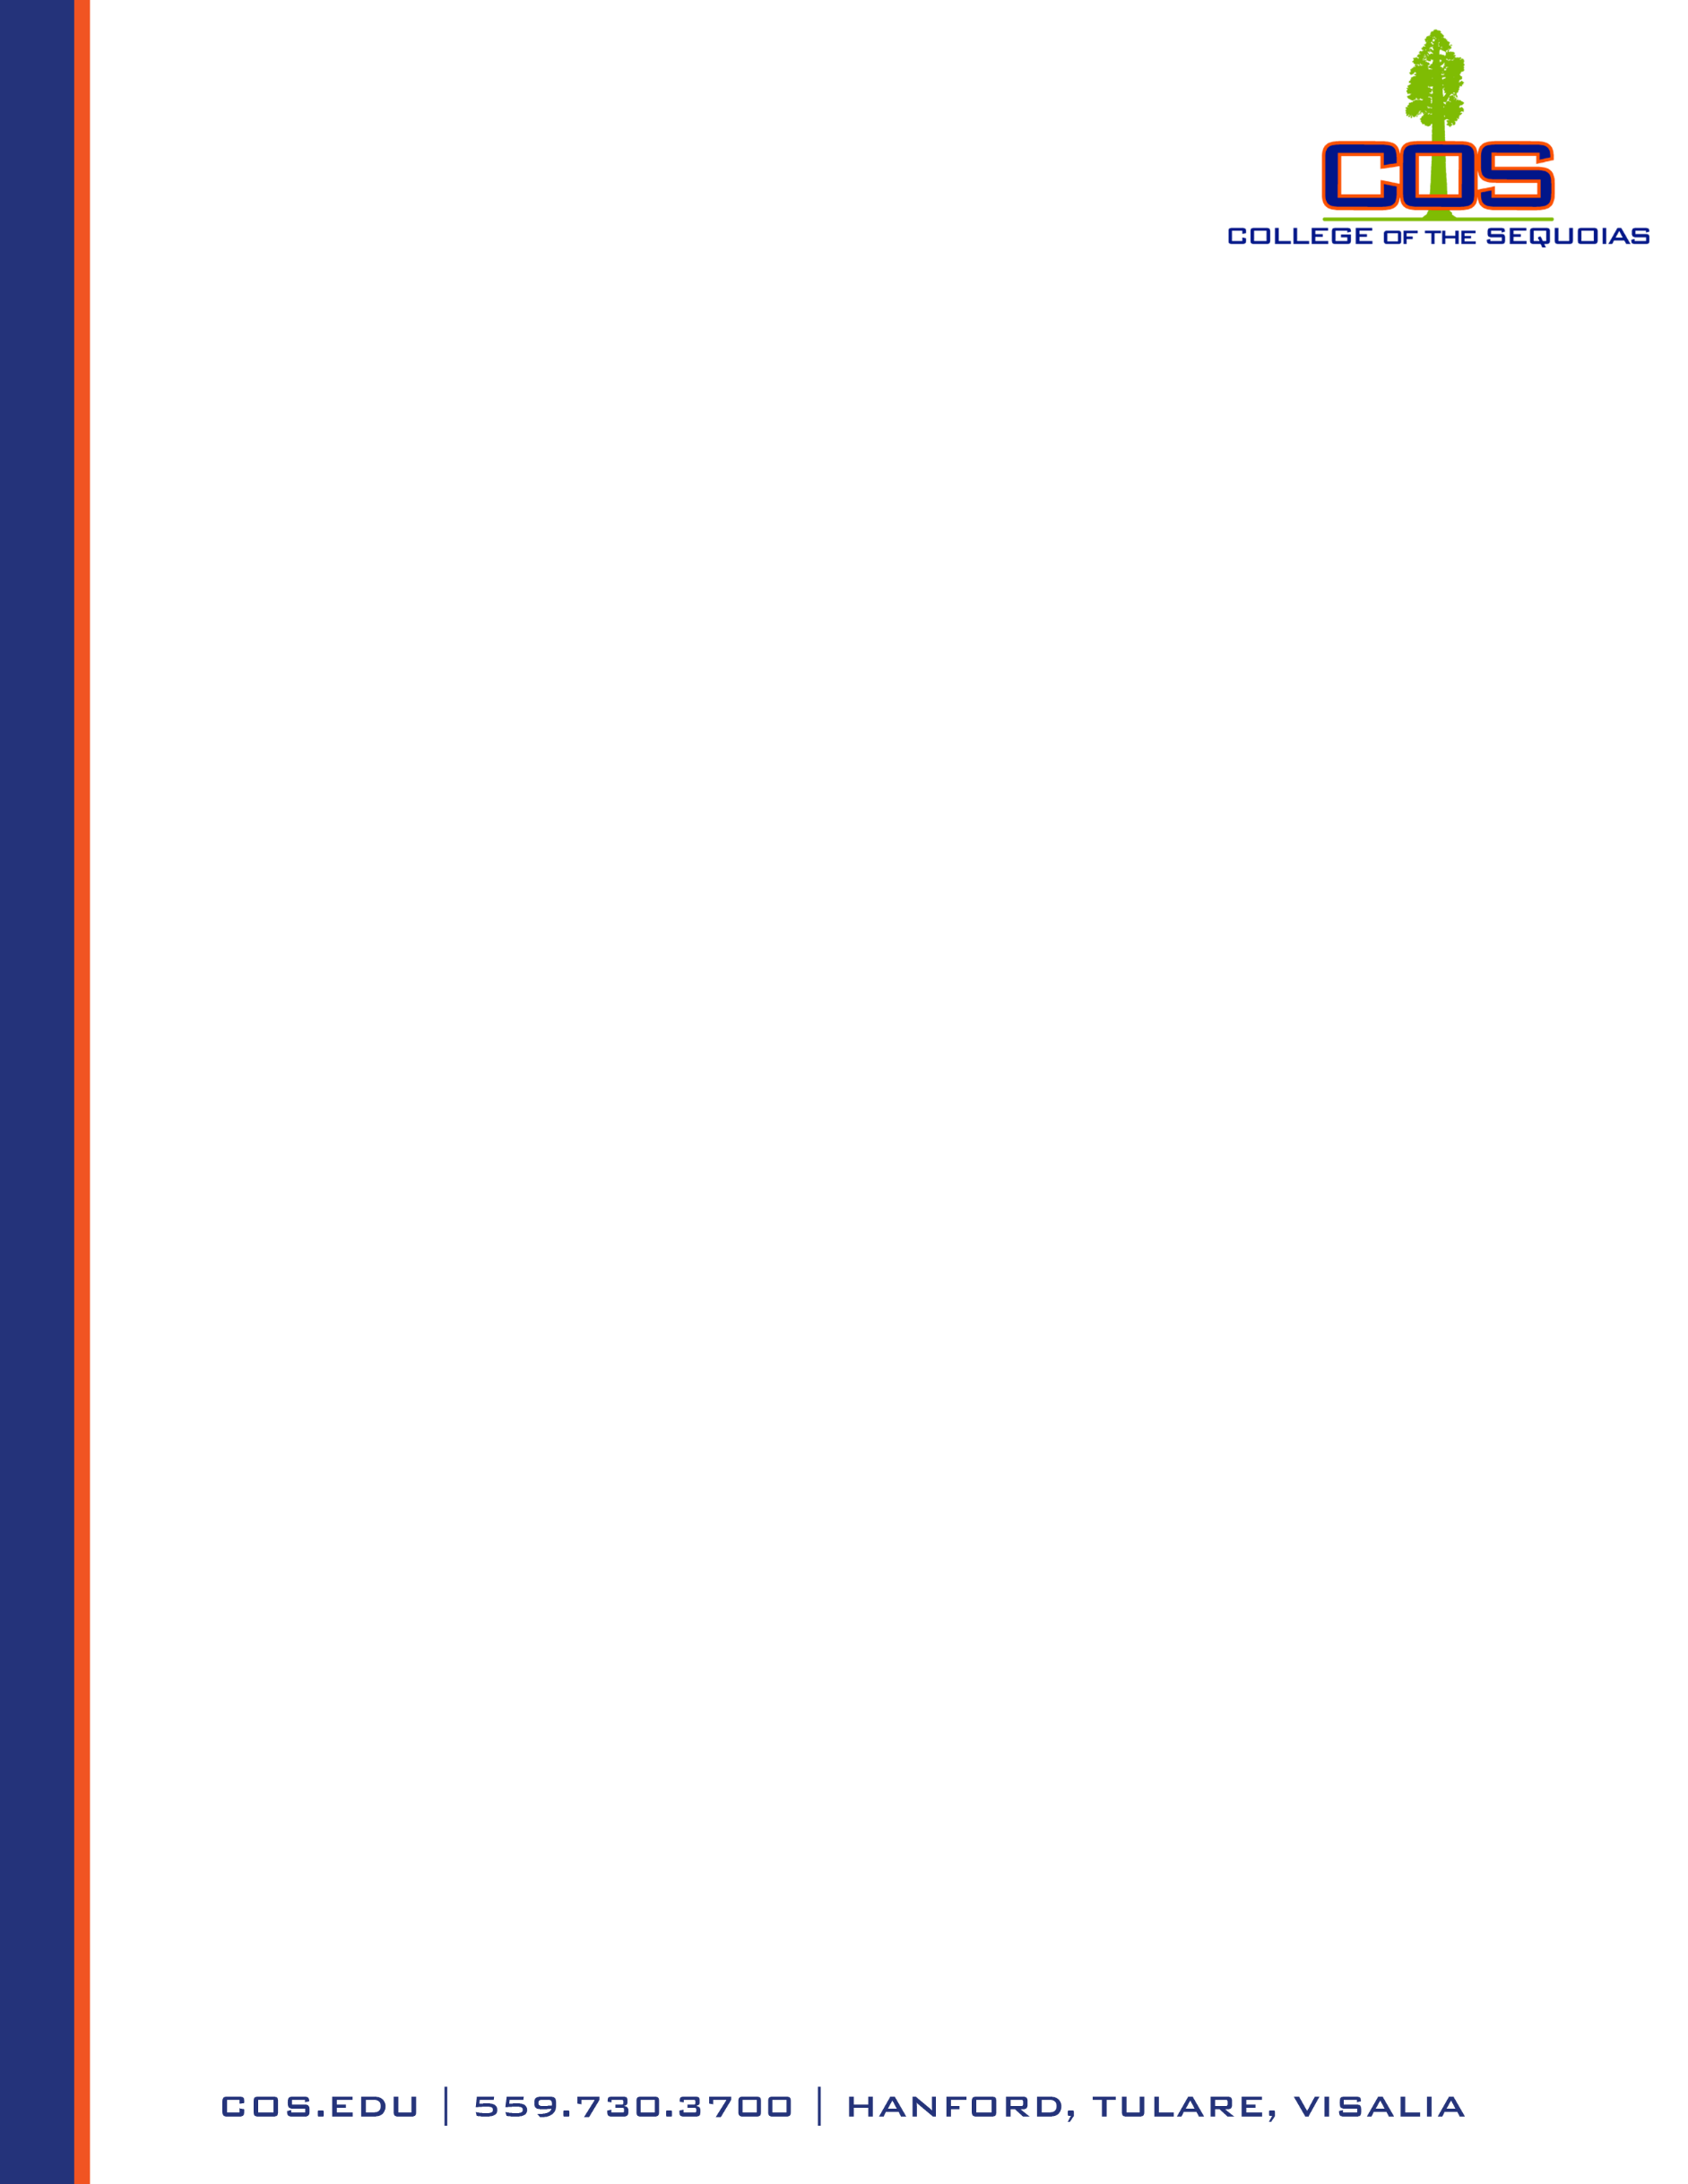
INSTITUTIONAL PROGRAM REVIEW COMMITTEE
Christian Anderson & Francisco Bañuelos, Co-Chairs

February
Meeting Minutes – Tuesday, March 17, 2026
4:00pm

Attendance (via Zoom)
Members present: Christian Anderson (co-chair), Francisco Bañuelos (co-chair), Chelsea Cushing, Dali Ozturk, Daniel Rivas Chris Spomer
Members absent: Erik Arteaga, Kourtnie Haney, Timothy Houk, Shailin Kennedy, James McDonnell, Jeremy Petty
Guest attendance: Ashley Fisher, MSE Administrative Assistant (minutes)

- Call to Order: Meeting was called to order at 4:00 pm.
- Agenda Item 1 – Review Minutes from February 17, 2026.
  - Minutes: The minutes for previous meetings were approved by ascent.
- Agenda Item 2 – 2026 Annual Joint Meeting with O&A, Budget, IPEC, and IC.
  - Updates to 2025 Agenda:
    - Keep the structure of the meeting the same format, just lighter.
    - Report back the changes that were made based on the feedback from last year’s meeting.
    - Ask for feedback from each committee
      - How does PR impact for their work?
      - Improvements for IPRC?
      - Any new changes since last year’s meeting, anything that was missed?
      - Ask the committees to share their own rubric that might involve program review; changes they may have made to their rubric; suggestions they might.
    - Keep the closing question the same: “Does the IPRC understand the needs articulated by the _______ committee?”
    - Next Steps: Review draft agenda at the next meeting.

- Agenda Item 3 – Other Business or “Good of the Order”
  - Initiative update: Some of the scripts and storyboards for the short training videos are complete. Goal is to have videos created by the end of the year.

Meeting adjourned at 4:19pm.

Kindly submitted,
Christian Anderson, IPRC Co-Chair
Francisco Bañuelos, IPRC Co-Chair

